Castle

* Stone
  + Moss?
    - Greenish
  + Greys
  + Add colour elsewhere
  + Use different stones to break up the grey

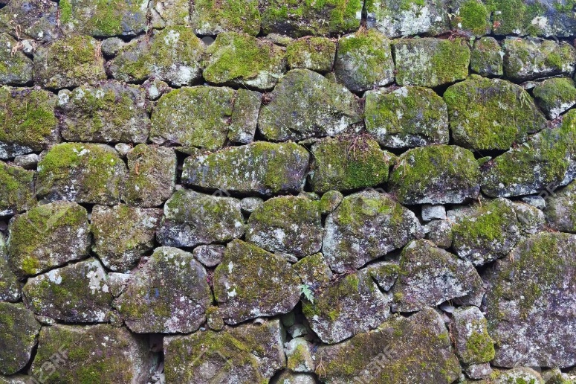

* Background
  + Castle Interior Wall
    - Decorations for colour
      * Paintings
      * Banners/Tapestries
      * Lights
        + Lanterns
        + Sconces
      * Weapons
      * Doors
    - Rubble

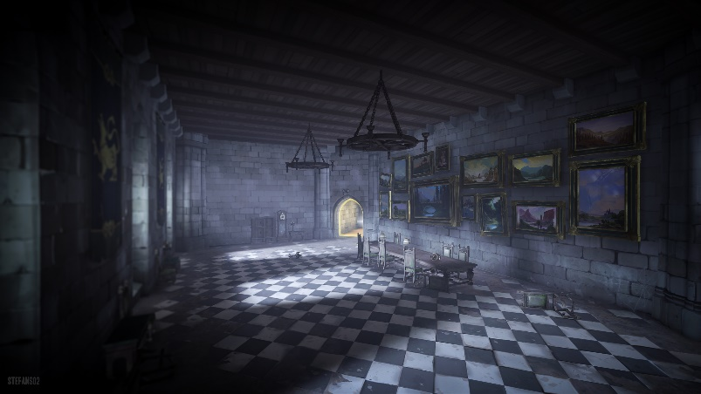

Village (tutorial)

* Villagers?
* Path
  + Dirt
  + Mostly Grass Free
* Non-path
  + Overgrown
* Background
  + Buildings
    - Low Quality
    - Run-Down
    - Wood and Straw

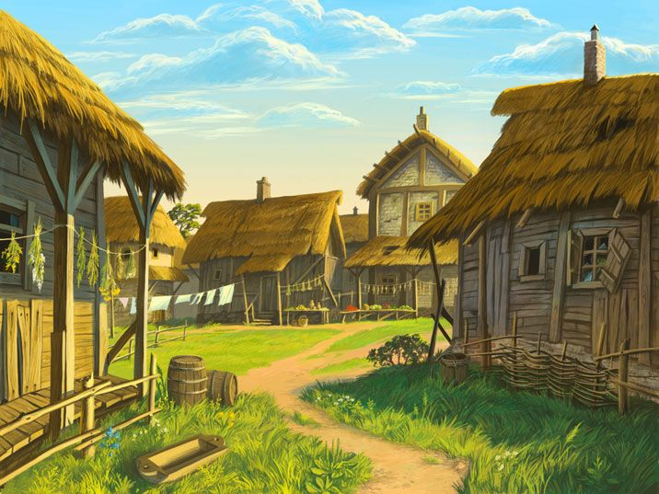

Enemies

* Knights
* Bandits
* Suits of Armour

Traps

* Lava pit
* Spike pit

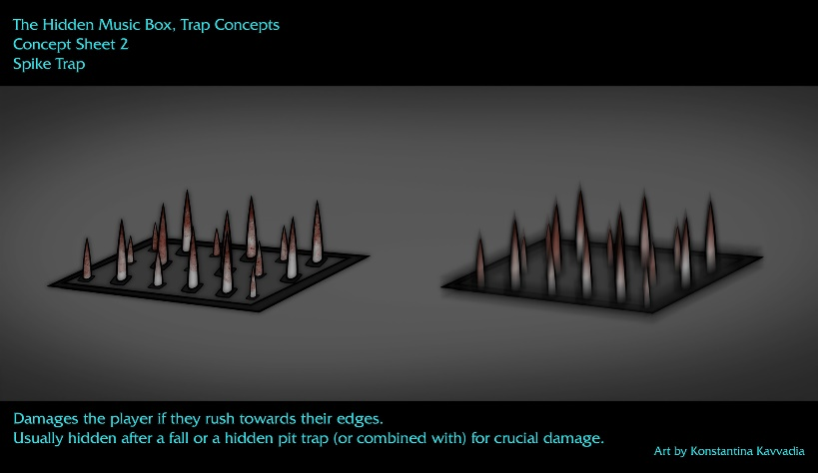

* Arrow trap
  + Trigger plate
  + crossbow